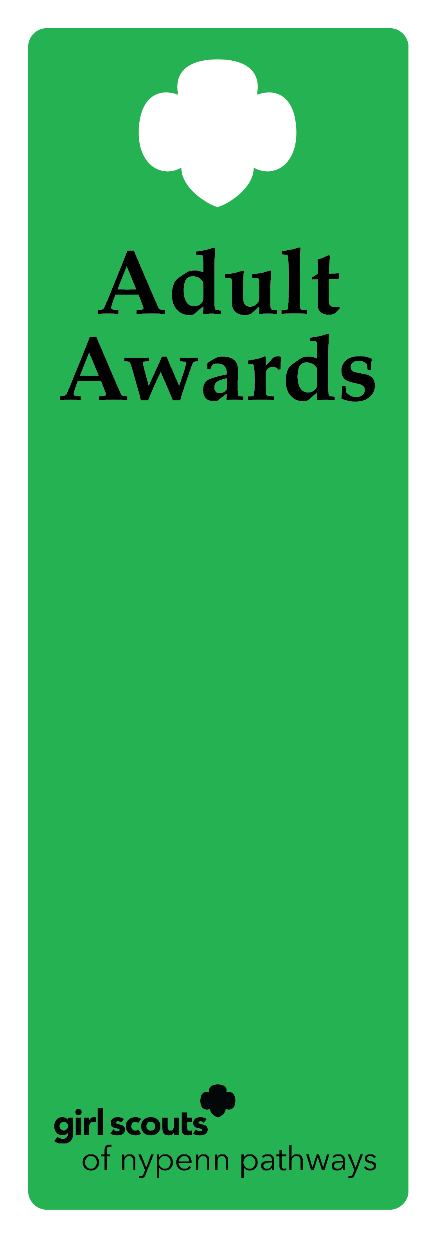
Trefoil Award

Description
This award recognizes a Girl Scout volunteer team within Girl Scouts of NYPENN Pathways. This team works together to accomplish amazing goals.

Criteria
- All members of the team must have a minimum of three years volunteering.
- The team’s efforts must have created a meaningful impact for more than one geographic area (not just one troop or service unit).
- The nominees have performed beyond the expectations for the position to deliver the GSLE to girls using the National Program Portfolio.
- The nominees actively recognize, understand and practice the values of inclusive behavior.
- The nominee has not previously received the Trefoil Award.

Nomination
A nomination form is completed and submitted to the council’s recognition committee, along with supporting documentation indicating how the nominee meets the criteria. The recognition committee reviews the nomination documentation, then approves or denies.

Example of nominee
            - A volunteer team works together to create a day camp program. The day camp hosts 100 Girl Scouts annually and provides a new experience to those who would not otherwise have an outdoor experience.
            - A volunteer team initiates starter troops throughout the county. The team hosts troop meetings and coaches new troop leaders. As a result, new troops are successfully starting in multiple units.

