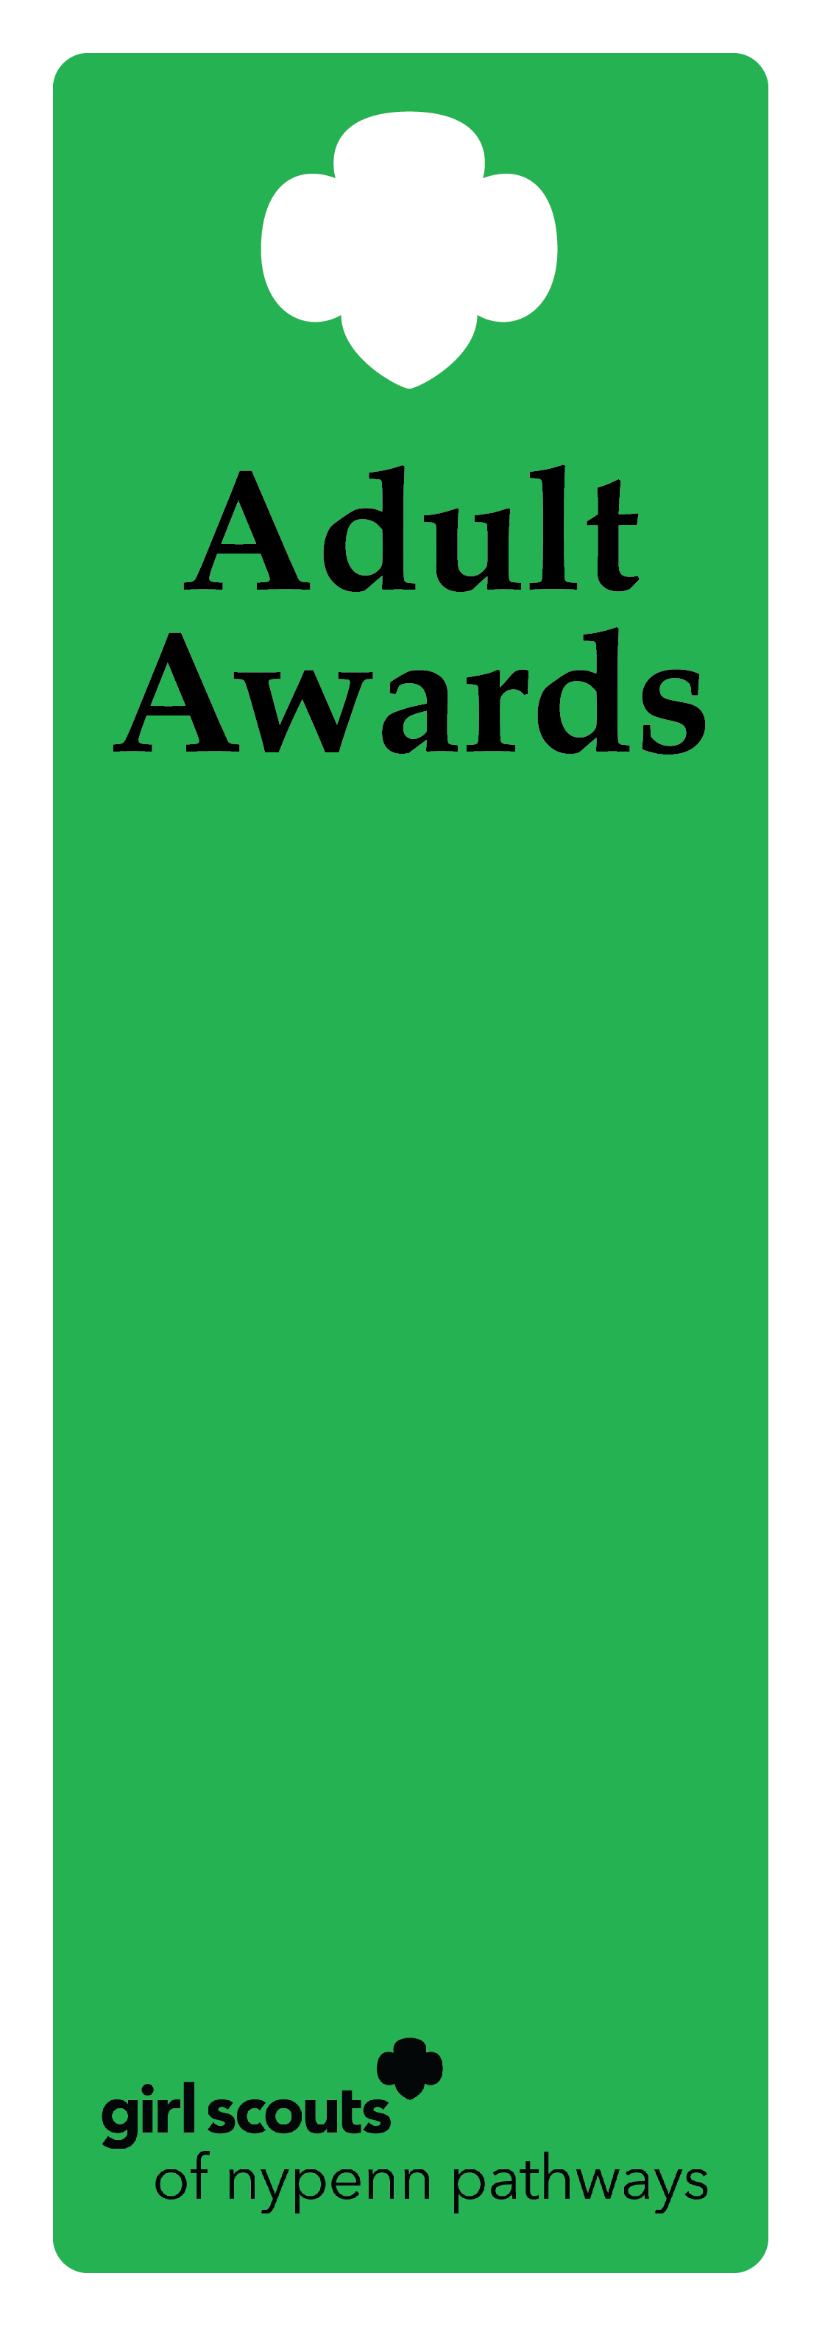
Thanks Badge

Description
The Thanks Badge honors an individual whose ongoing commitment, leadership and service have had an exceptional, measurable impact on meeting the mission-delivery goals and priorities of the entire council or the entire Girl Scout Movement.

Criteria
- The nominee is an active, registered adult Girl Scout.
- The outstanding service performed by the nominee resulted in outcomes that benefited the total council or the entire Girl Scout organization, and is so significantly above and beyond the call of duty that no other award would be appropriate.
- The nominee has not previously received the Thanks Badge

Nomination
A nomination form is completed and submitted to the council’s recognition committee, along with supporting documentation indicating how the nominee meets the criteria. The recognition committee reviews the nomination documentation, then approves or denies.

Example of nominee
            - A volunteer recognized a need for an opportunity to network with fellow volunteers. The volunteer organized a social media platform welcoming all volunteers to share information and opportunities with eachother. The result is a more connected and empowered volunteer network.

