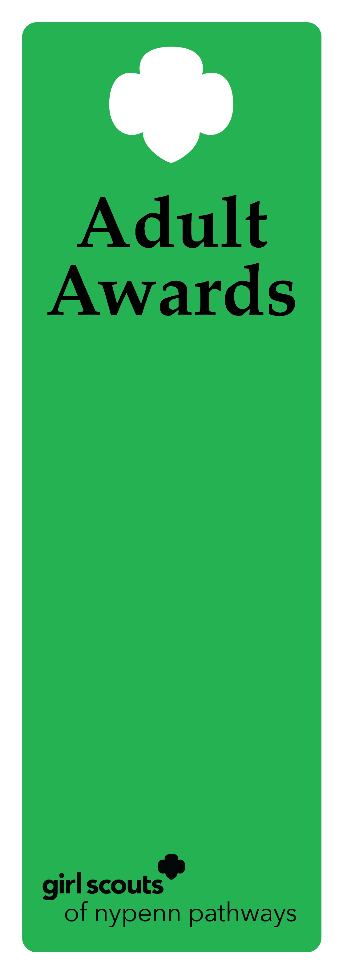
Spirit Award

Description
This award recognizes a volunteer who supports the Girl Scout Movement within the Girl Scouts of NYPENN Pathways. The recipient is known to work diligently behind the scenes, is first to provide extra assistance and supports fellow Girl Scout volunteers and the troop.

Criteria
- The nominee must be a volunteer for a minimum of two years.
- The nominee is an active, registered adult Girl Scout.
- The nominee has successfully completed a term of service and all requirements for the position.
- The nominee has performed beyond the expectations for the position to deliver the GSLE to girls using the National Program Portfolio.
- The nominee actively recognizes, understands and practices the values of inclusive behavior.
- The nominee has not previously received the Spirit Award.

Nomination
A nomination form is completed and submitted to the council’s recognition committee, along with supporting documentation indicating how the nominee meets the criteria. The recognition committee reviews the nomination documentation, then approves or denies.

Example of nominee
            - A volunteer of 5 years that consistently steps up and supports the troop leadership. They do all the shopping, ordering and preparing countless activities for the troop.
            - A volunteer of 10 years that holds a position on the service unit team. They consistently mentor and support new volunteers to ensure they have a strong and memorable first year in Girl Scouts.

