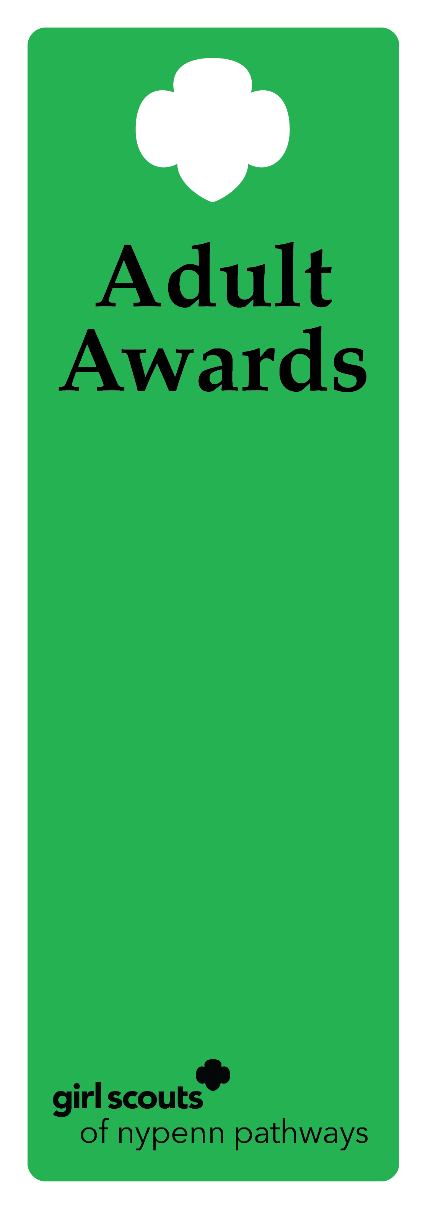
Honor Pin

Description
The Honor Pin recognizes an individual's exemplary service in support of delivering the Girl Scout Leadership Experience (GSLE), which has had measurable impact on two or more geographic areas of service, allowing the council to reach and surpass its mission-delivery goals.

Criteria
- The nominee is an active, registered adult Girl Scout.
- The service performed by the nominee is above and beyond the expectations for the position held and made an impact on two or more geographic areas within the council’s jurisdiction.
- The nominee has not previously received the Honor Pin.

Nomination
A nomination form is completed and submitted to the council’s recognition committee, along with supporting documentation indicating how the nominee meets the criteria. The recognition committee reviews the nomination documentation, then approves or denies.

Example of nominee
            - A volunteer facilitator has a select skill set and enjoys facilitating outdoor trainings for both adult and youth membership. The facilitator has hosted trainings spanning ten counties within GSNYPENN. As a result, countless troops and members have access to additional outdoor experiences.

