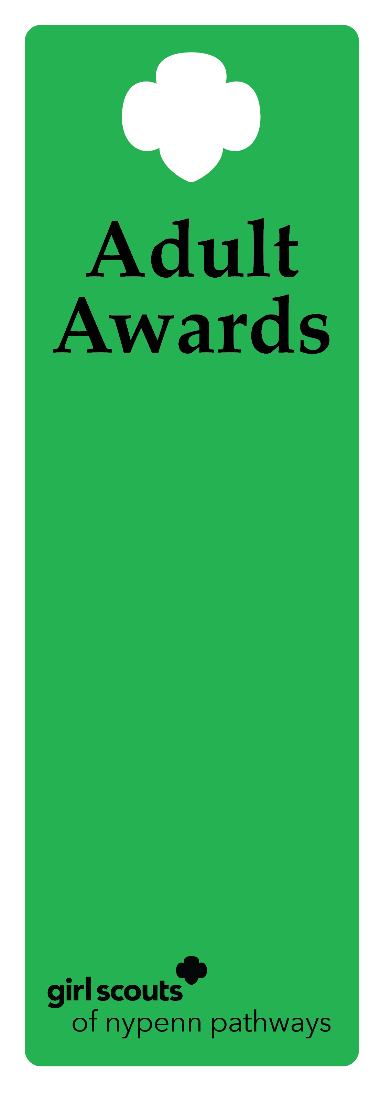
Hall of Fame Award

Description
This award recognizes a lifetime commitment to the Girl Scout Movement within the Girl Scouts of NYPENN Pathways. The recipient has supported NYPENN in a variety of ways including; supporting Girl Scouts in the community, volunteering in a variety of roles and financially supporting NYPENN.

Criteria
- The nominee must be a volunteer for a minimum of 20 years.
- The nominee must be a previous recipient of the Appreciation Pin, Honor Pin, Thanks Badge, Thanks Badge II and Ever-Green Award.
- The nominee has financial supported Girl Scouts.
- The nominee is an active, registered adult Girl Scout.
- The nominee has successfully completed a term of service and all requirements for the position.
- The nominee has performed beyond the expectations for the position to deliver the GSLE to girls using the National Program Portfolio.
- The nominee actively recognizes, understands and practices the values of inclusive behavior.
- The nominee has not previously received the Hall of Fame Award.

Nomination
A nomination form is completed and submitted to the council’s recognition committee, along with supporting documentation indicating how the nominee meets the criteria. The recognition committee reviews the nomination documentation, then approves or denies.

Example of nominee
            - A volunteer of 25 years that has led multiple troops, been the Service Unit Manager and a facilitator of multiple counties within the council. She has also contributed to our annual giving campaign in endless support of NYPENN.

