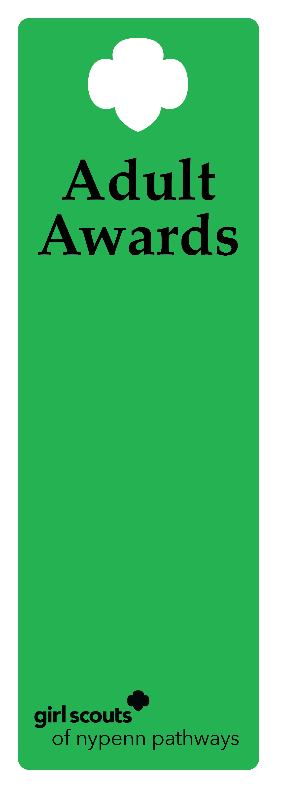
Ever-Green Award

Description
This award recognizes a volunteer that has previously received one of the following awards: Appreciation Pin, Honor Pin, Thanks Badge or Thanks Badge II. The volunteer has continued to provide amazing efforts for a minimum of two years after award.

Criteria
- The nominee is a previous recipient of a GSNYPENN or GSUSA award.
- The nominee must have continued service for two years since the previous award.
- The nominee is an active, registered adult Girl Scout.
- The nominee has successfully completed a term of service and all requirements for the position.
- The nominee has performed beyond expectations for the position to deliver the GSLE to girls using the National Program Portfolio.
- The nominee actively recognizes, understands and practices the values of inclusive behavior.
- After the initial Ever-Green Pin, awardees will receive a guard.

Nomination
A nomination form is completed and submitted to the council’s recognition committee, along with supporting documentation indicating how the nominee meets the criteria. The recognition committee reviews the nomination documentation, then approves or denies.

Example of nominee
            - A Service Unit Manager has previously been awarded the Honor Pin for establishing an annual event for multiple counties. The leader has continued to expand on this event for the past three years and deserves to be recognized again.

